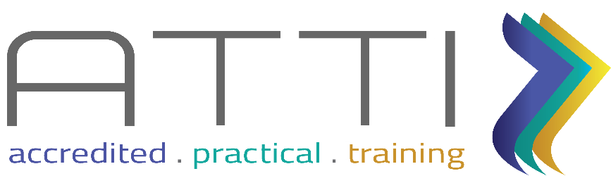

**Statement and Confirmation of Own Work**

Student Declaration

I have read and understood ATTI IT Solutions Assessment Submission guidelines and Academic Dishonesty and Plagiarism polices.



I can confirm the following details:

**Student:** Rebone Kgoshe

**ID / Passport 9309251250086**

**Qualification:** National Certificate: Information Technology (Systems Development)

**Qualification ID 48872**

**Institution:** ATTI IT Solutions

**Unit Standard 114048**

**Unit Standard Title: Create database access for a computer application using structured query language.**

**Credits 9**

**NQF NQF Level 5**

**Due Date: 15 June 2023**

I declare that the work submitted is my own work and that I have not plagiarised any part of it. I have also noted the assessment criteria and pass mark for assignments.

Signed: kgoshe

**Practical Assessment**



